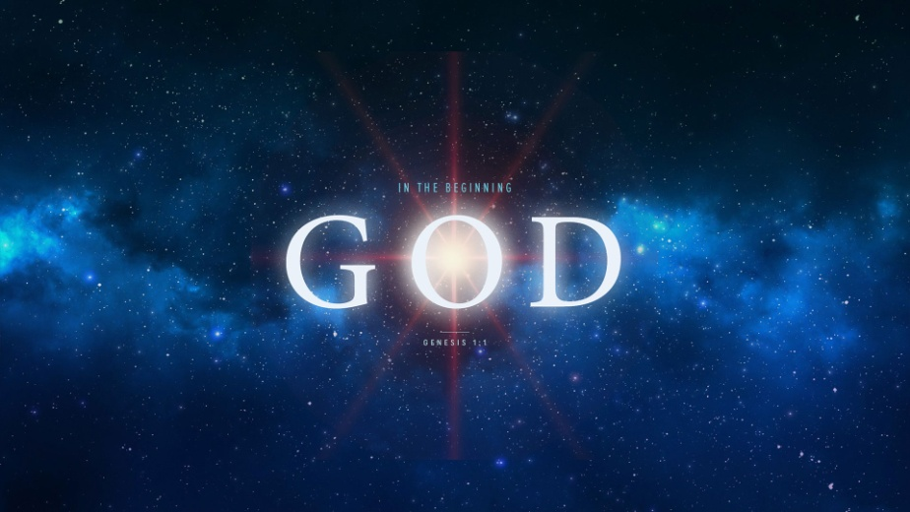
Genesis 1:1
1. God’s Existence
- The Cosmological Argument (Cosmos: Universe)
- Logic: The universe must have had a Beginning
- Size: The universe is Immense
- The Teleological Argument (Teleos: Design)
- Design and Beauty are evident in the universe
- They imply a Designer
- The Anthropological Argument (Anthropos: Man)
- All mankind has a moral nature, a conscience
- If there is a Moral Law, there must be a Law Giver
- The Universal Argument (Worldwide belief)
- Countless tribes & people groups believe in a god
- The heavens declare the Glory of God; Psalm 19:1
- God placed in man a desire to seek after Him
2. God’s Characteristics
- He is Eternal
- He has no beginning or ending
- He is Mighty
- He was not created; He created all things
- He is Sovereign
- He is Supreme; All creation will bow before Him
Honolulu Assembly of God In the Beginning God July 12, 2018

