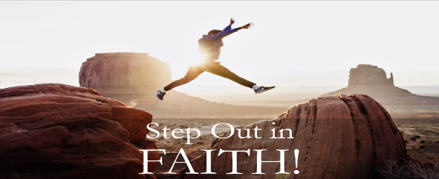
Noah: Faith to Overcome the Impossible!
Hebrews 11:7; Genesis 6:5-8
A. Noah’s Life
- God’s Sorrow; 6:5-7, 11-13
- Jesus likened the time of His return to the “Days of Noah”
- When man was at his Worst, we see God at His Best
- Noah’s Calling; 6:8
- Noah did not allow the Evil standards of his day to rob him of Fellowship with God
- Mankind’s Salvation; 6:14-21
- The Ark was the Largest sailing vessel man had ever seen
- The World’s Catastrophic Flood; 7:17-24
- It would have been a Terrifying experience
- God’s Covenant; 8:18-22; 9:8-16
- God would never again destroy the world by Water
B. Noah’s Faith
- Noah had Faith to Believe God’s Word
- The Ark must have seemed like the Craziest thing to do
- But Noah did not Argue with God; he Obeyed God
- Noah had Faith to Build an Ark
- Our wisdom might seem best to us, but not compared to God’s wisdom
- It is not enough to Believe; we must put Feet to our Faith
- Noah had Faith to Obey God in spite of all the Naysayers
- The Majority of people in his day rejected his message
- Do you have Courage to stand for Christ even when it is not Popular?
- Noah had Faith to preach for generations with No results
- We can’t live on Emotions or go by our Feelings
- God does not require Results; He requires Obedience
Honolulu Assembly of God Step Out in Faith! January 11, 2026

