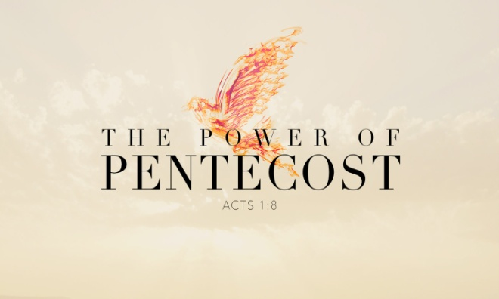
Why do we need the Holy Spirit’s empowering?
1. For Signs and Wonders
- Signs and Wonders are Not the End result
- Miracles create an Environment for the Communication of the Gospel
- God Intervenes, Jesus is Exalted and lives can be Transformed by the power of the Holy Spirit
2. Spiritual Intercession
- Have you ever wondered What or How to pray?
- Pray in the Spirit with Groans that words cannot express, Romans 8:26-27; Tongues are your Hotline to Heaven
- If you only pray in your Mind, how can the Holy Spirit begin to use your tongue to Praise Jesus?
- When you don’t know what or how to pray in English, pray in a Heavenly Language
3. Live an Overcoming Christian Life
- Ever felt Flat spiritually? Inadequate and Insufficient?
- You need the Overcoming power of the Holy Spirit in your life
- Use the Power Tool of the Baptism in the Holy Spirit
4. Power for Witnessing
- The Holy Spirit is available to bring you to an whole nother level
- God knows your Personality and He can use it for His Glory
- He desires to move you from Where you are to where He wants you to Be
Honolulu Assembly of God May 30, 2021

