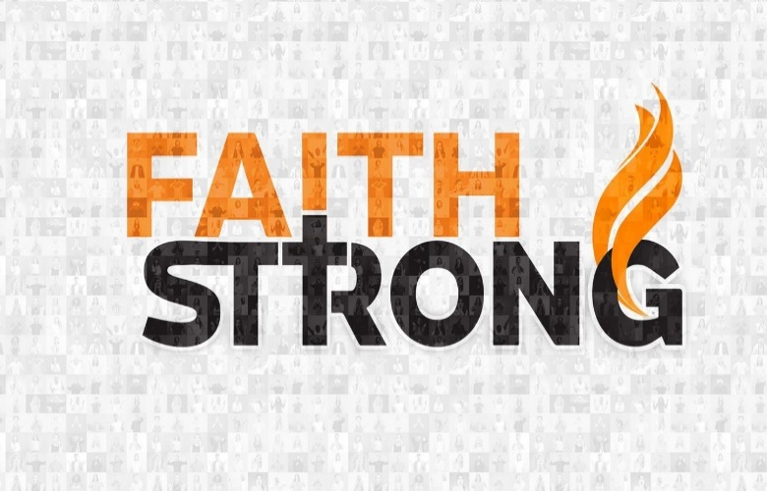
Walk in the Spirit! Galatians 5:16-18, 25

A. What does it mean to Walk in the Spirit?
- Initially it meant for me Confusion
- It all seemed Strange and Mystical
- Christianity is Mysterious, not Mystical
- Then I grew in Understanding (3 prepositions)
- Walk With the Spirit
- Walk By the Spirit
- Walk In the Spirit

B. Change your Clothes
- Put Off the Old Nature v17-21
- You have two natures: your Old nature and your New nature
- They are at War with one another v17
- Don’t sit on the Fence; you must Crucify your Old nature v24
- Put On the New Nature v22-25
- It is not about Self Control but about a new Affection
- Choose Against the Old nature and For the New nature
- It is not about what you Give Up but about what you Get
- Christianity is not about giving up your Desires but about gaining Jesus; Philippians 3:8-9
- Don’t walk by Sight
- Walk by Faith
Digging Deeper: Am I stumbling and struggling to live an overcoming Christian life? Or am I learning to rely on the explosive power
of the Holy Spirit in my life?
This Week: Walk in the Spirit! Ride on the Wind of the Spirit! Ask Jesus to give you courage to step out in faith, relying on His powerful Holy Spirit.
Honolulu Assembly of God Faith Strong! October 1, 2023

