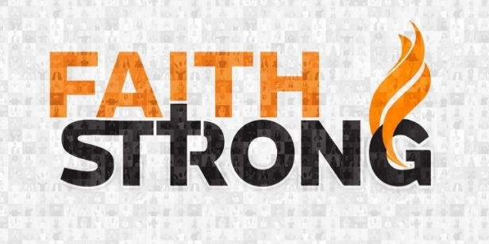
Get Ready to Possess the Land! Numbers 13

A. A Vision of the Opportunity = Perspective
- 12 spies: Find out Everything you can about the land and people
- We need to look through the eyes of Vision and Faith

B. A Decision to Take Action = Response
- In any endeavor there are Two groups of people
- Nay-sayers: Discouragers; People who Squelch the Vision
- Encouragers: Risk Takers! People who say Yes to the Vision
- Jesus has not called us to preserve the Past or maintain the Status Quo
- Stepping out in faith involves Risk
- For many people, Threat outweighs the blessing of Victory
- For others, the Blessings outweigh the Dangers
- Joshua and Caleb also saw Giants, but they saw God as bigger than the giants
- Victory is ultimately determined by the decision to go Forward

C. There are Consequences when we Refuse to enter in to possess the Land
- By choosing to Live in Fear and Doubt, we choose to Live in Defeat
- By not entering in by Faith, they stopped the Blessing
- We either choose Vision and Growth OR Pettiness and Arguments
- Key: You cannot stay where you Are; By not going forward, you are choosing to go Backwards
- They were sentenced to Wandering in the wilderness for 40 years due to Unbelief
- Sad: None of that generation were able to enter the Promised Land
This Week: Attempt something so Daring
that it is bound for Failure if Jesus does not Intervene
Honolulu Assembly of God Faith Strong! October 29, 2023

