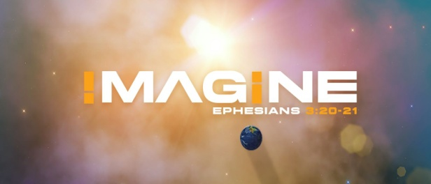
A. He is the Lord of Limitless Possibilities
- How do you View God? How Powerful do you think He is?
- Is He All Powerful?
- What Limitations are you putting on Him?
- God has yet to experience a Challenge; Genesis 18:14
- He has no Equal or Competition
- Your biggest Problem won’t even cause God to break out in a Sweat
- Nothing is too hard for the Lord!
- No matter how Bold our requests may seem, the Lord can do All we ask and much More
- The best-case scenarios in our minds are Nothing compared to what God promises to Do
B. He has prepared Possibilities Beyond our Imagination
- There are Many possibilities beyond our ability to Imagine; Genesis 15:5
- Our eyes must be Opened to See and Understand; Eph 1:18-19
- It is the Spirit who Unveils God’s profound realities to us; 1 Cor 2:9-10
- We don’t have the Capacity to know what all to ask for
- Have your eyes been Opened to know the Truths of God?
- Or are you living acc to the World’s system and agenda?
C. Faith opens our Spiritual Eyes to see the Impossible things of God
- Are you seeing the Possibilities or the Impossibilities? Genesis 13:10-17
- Abraham got the Other land that Lot did not want
- But the Lord told him to Lift up his eyes and see the Possibilities
- Your Imagination will make the Difference for you both Now and in the Future
- It will either result in Faith to see the endless Possibilities;
2 Corinthians 4:18
- Or it will result in Fear to see the endless Problems
Honolulu Assembly of God February 6, 2022

