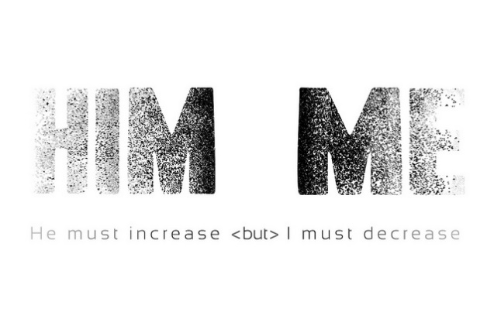
John 3:30
A. John the Baptist’s Example
- John had an Incredible ministry; the response of people was Overwhelming
- John was called to Prepare the way of the Lord
- It could have been tempting to him to try to keep Control
- John never lost perspective, but his Disciples did; it was all about Competition and building their own Kingdom v25-26
- John’s response was great Humility; he knew his Role v27-29
- It is not about Getting or Taking, but Receiving the gifts from God
- The beautiful Morning Star was fading under the growing brilliance of the light of the Rising Sun v29
B. Jesus must Increase
- Choose to have Jesus become Greater in your life
- Have you come to the place of Surrender? Or are you still struggling for Independence?
- Give Jesus Christ complete Rulership over your life; Galatians 2:20
- May there be Less of me and More of Him
- The Christian life is the process of Daily letting Jesus have more Control
C. I must Decrease
- I must become Less and Less
- It is not about becoming a Useless and Worthless person
- Don’t confuse Humility with low Self-Esteem
- True Humility is not thinking Less of Yourself; it is thinking of yourself Less
- Ask Jesus to Forgive you of Sin and Empty you of Self so He can Fill you with Himself
Honolulu Assembly of God January 7, 2024

