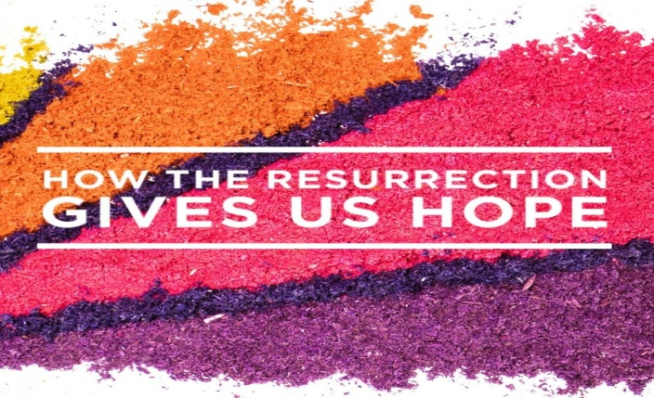
John 20:1-10
1. We have been completely Forgiven
- Jesus Christ made a Promise: I am going to Die and then Rise again
- Who put Jesus on the Cross?
- Not Judas and the Jews, nor Pilate and the Romans
- God the Father; Isaiah 53:6-10
- We did; Romans 3:25-26; 4:25
2. We are no longer Afraid to Die
- There is a universal Fear of Death
- How can we explain the change in Christ’s followers from Terrified men and women to Bold witnesses?
- They were Eyewitnesses to the Miracle of the Resurrection;
1 Corinthians 15:3-8; 2 Peter 1:16
3. We now have God’s Spirit in us
- Jesus promised the Coming of the Holy Spirit; John 14:15-17
- God never intended for you to live in your own Power
4. God will never stop Loving us
- He loved us First; Jeremiah 31:3
- John 3:16-17; His Love will make a Difference in your life
5. We have an Eternal Home waiting for us
- Death is not the End; it is a Transition
- We have a Mansion waiting for us; John 14:1-3
- Heaven will be More than you could ever Imagine
- You will spend much more Time in Heaven than here on earth
- If so, shouldn’t you Prepare for it? John 14:4-6
Resurrection Sunday April 4, 2021 Honolulu AG

