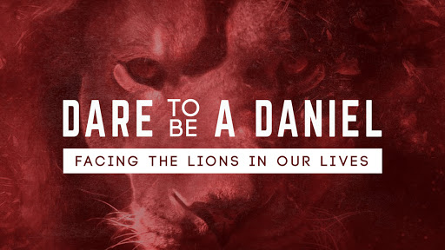
Daniel 6:1-28
Daniel had Faith to Stand Strong!
A. In spite of Opposition; v1-5
- Daniel is now an Old man
- But he is a Threat to the other administrators
- Daniel’s enemies look for a way to Ruin him
- They realize they can only ruin him through his Faith in God
B. In spite of the King’s Edict; v6-9
- Daniel’s faith was not his Weakness but his Strength
- Just like Daniel, our Strength comes from our faith in God
- Did Daniel Know of the command that he was not to pray? Yes!
- Could Daniel have Hidden his prayer time? Yes!
- He was Boldly declaring that he loved God too much to dishonor Him
C. In spite of the Threat of Death; v10-18
- Daniel was willing to Stand for God in spite of the Consequences
- He faced Death by hungry lions
- Kings kept lions for Sport and to prove their Courage
- Daniel is Not a mighty warrior who can defeat lions
D. In spite of the seeming Absence of God’s Intervention; v19-28
- Daniel is seen here as a man of Courage and Faith
- Daniel slept because he knew he was not in Danger
- Don’t be Afraid to stand up for God
- When you stand up for God, it just might Change the world around you
- We walk by Faith and not by Sight
Honolulu Assembly of God March 7, 2021

