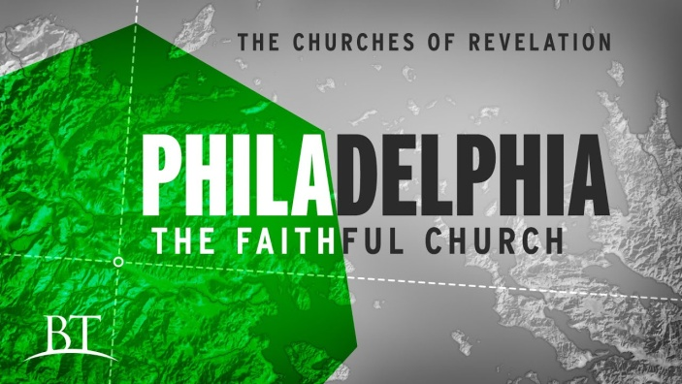
Seize the Day!
Revelation 3:7-13
1. Commission v7
- The Background of the Ancient City of Philadelphia
- Status Today
2. Character v7
- Who is He?
- The Holy One
- The True One
- What does He do?
- He holds the Key of David
- What He Opens no one can Shut
3. Commendation v8-10
- Their Deeds
- You have a Little Strength
- But you are Faithful
- Their Open Door
- Jesus wants you to See and Seize the Opportunities
- What Impact could we make if we would Step Out in Faith to walk through the Open Doors God has given us?
4. Promises
- Certainty
- I am Coming soon; v11
- Victory
- I will Bless you; v9-10
- Security
- I will Keep you; v12
- Identity
- I will give you a new Name; v12
Honolulu AG 7 Letters to your Church November 8, 2020

