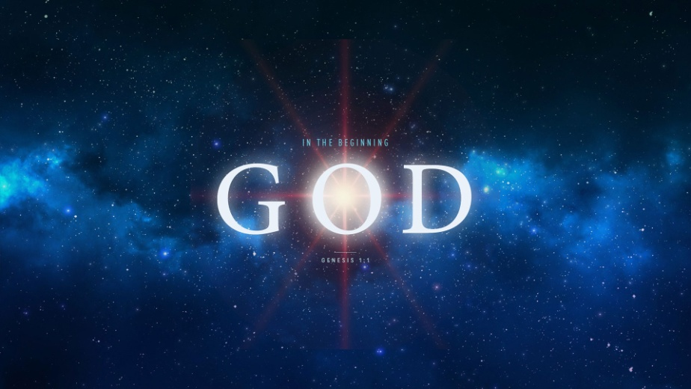
In the Beginning God Created Woman
Genesis 2:18-25
1. Creation defines the Difference between Man and Woman
- We have been created Male and Female
- We have become One in Christ
- We discover our True Identity in Christ
- We discover our True Freedom in Christ
- You are a Unique Creation of God
2. Creation defines the Relationship between Husband and Wife
- The Relationship of Wife to Husband: “Help Meet for her husband”
- God’s Announcement (2:18) and parade of Animals
- God made a Decision to Make a Companion for Adam (‘ezer kenegdo)
- God made Eve from Part of Adam; 2:22-23
- Wives, you are a Help Suitable for your husband
- The Relationship of Husband to Wife: “Receiver of a precious gift”
- Husbands, do you Cherish your precious gift from the Lord?
- Are you faithful to Love and Protect her?
Honolulu Assembly of God In the Beginning God! August 2, 2018

