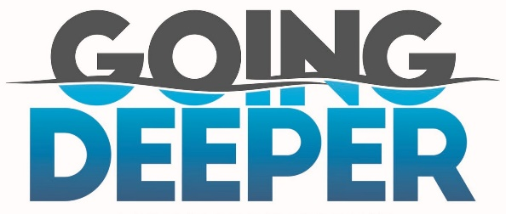
Only Jesus! 2 Corinthians 12:9-10
A. My Weakness = His Strength v9-10
- Jesus: My Grace is Sufficient for you
- My Power is made Perfect in Weakness
- Paul: Therefore, I will Boast about my Weaknesses
- So Christ’s Power may Rest on me
- For Christ’s sake, I Delight in Weaknesses
- When I am Weak, then I am Strong
B. Sovereign
- Jesus is in Control! He reigns Supreme
- He has All Authority! He is Lord and Master
- He knows what is Best
- All Time is before Him
C. Surrender
- Since Jesus knows All, we can Trust Him
- He already knows the Answer
- Paul wanted his own Way: He wanted Jesus to remove the Thorn
- Christian life: Don’t Strive! Don’t try to do your Best
- You can’t live the Christian life in your own Ability
- Let Jesus Live His life in you; He is the only One who Can
- The Goal for you is to Become like Jesus
- Don’t Strive! Come to the place of Surrender
- Surrender is the place of Strength
D. Strength
- My Weakness Demonstrates Christ’s Power
- Jesus Transforms my Weakness into His Strength
Honolulu Assembly of God Going Deeper! March 3, 2024

