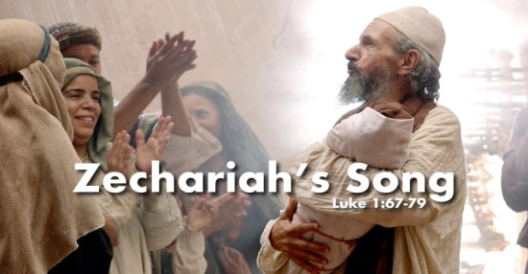
A. Zechariah’s Story v5-25, 57-66
- His Background
- Priestly lineage: Both from the line of Aaron
- They were Childless: The heartbreak of Barrenness v7
- Both Personally and Nationally
- 400 yrs of Silence with no Word from the Lord
- His Experience in the Temple v8-22
- A frightening Visitor with a staggering Announcement: He will have a Child
- Zechariah’s Response and Rebuke v18-20
- Rebuke due to lack of Faith: God had to Shut his mouth in order to Open his eyes
- Also a Confirmation about a coming miracle Baby
- Every time Zechariah cannot Speak is a reminder of Miracle that is going to happen
- Back Home: The Naming of the child v57-66
- Elizabeth Shocks her family with the name “John”
- The moment Zechariah writes the name “John”, his mouth is Opened and his tongue is Loosed v64
- He overflows with Praise and Worship
B. Zechariah’s Song v67-79
- Redemption: The Lord has Ransomed His people v68
- The Promise of the Covenant: God’s faithfulness to Israel v69-74
- God has a covenant with You; Romans 10:9-10; John 1:12-13
- He gives Freedom from our enemies and we can serve Him without Fear v71-75
- His Son’s Future: He will prepare the way for the Messiah, the Sun of Righteousness v76-79
Honolulu Assembly of God The Songs of Christmas December 12, 2021

