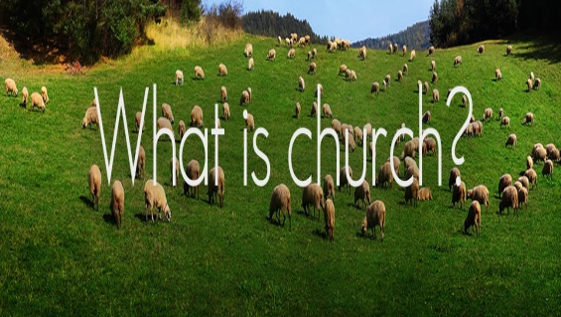
Ephesians 1:22-23
A. What the Church is Not
- It is not about a Building
- It is not about a Service
- It is not about a Denomination
- It is not about a Corporation
- It is not about an Audience
- It is not about a Social Center
- It is not about an Educational Center
B. What the Church Is
- The Church is a Body
- Jesus Christ is the Head and we are His Body;
1 Corinthians 12:12, 18-20
- We all have Spirtual Gifts that are essential to the work and ministry of the Body
- The Church is an Organism
- An organism is Alive
- An organism Reproduces
- An organism Grows
- The Church is a Community
- God has called His people to live and serve Together
- We are Ekklesia: His “Called Out” ones
- The Church Universal is called to identify itself Locally as a community of believers in a specific place
- The local church is the Invisible church made Visible
- The Church is a Fellowship
- Because of sin, man is prone to Hide
- In the Body of Christ, you are Free to Be yourself
- It is now safe to come out of Hiding and take off your Mask
Honolulu Assembly of God February 7, 2021

