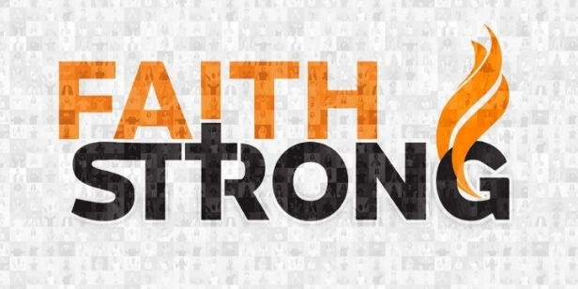
The Lord will do Amazing Things! Joshua 3:3-5
A. Move Forward v3
- Follow the Lord
- Jesus must have First place in our lives
- Step into the Water v15-16
- The waters did not divide until they Stepped in
- You cannot stay where you Are and hope things will Change
- Move Forward past your Comfort Zone
- Move out of the Known into the Unknown
- God has called us to a Spiritual Journey, not a Campout
B. Step Out v4
- In order to Go where you have never Gone before, you must be willing to Do what you have never Done before
- Same Choices = Same Results
- To See something New in your life, you must be willing to Do something New
C. Consecrate Yourselves v5
- Get Ready
- We can’t let Anything get in the way or Distract us from our Destiny
- Set yourself Apart for God
- Set apart and holy are not about Furniture but about People
Prayer: Dear Lord, I ask You to help me to be set apart for You.
I renounce the sins of this world and the hold of the enemy on my life.
I choose today to live in obedience to You and to stand on the solid ground that is Christ Jesus. Today I call on Your holy name and I ask You to help me to live for You as I walk this earth. Amen.
Honolulu Assembly of God Faith Strong! November 12, 2023

