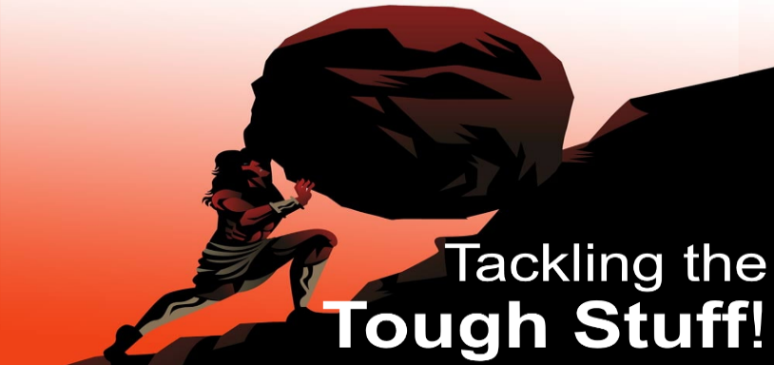
Failure
Stepping Stone
to Success!
Romans 8:35-39
A. Examples
- Judas and Peter
- Moses
B. Lessons
- Learn from Failure
- Everyone fails
- It is not a License to Fail or Freedom to Sin
- It is just a Fact! Peter failed, Moses failed, you and I will fail
- Failure is not Final
- Failure reveals our Utter Dependence upon Jesus and His Grace
- Turn from Failure
- Don’t Reside there
- Failure is not a Resting place but a Starting place
- Push through it
- Live in the glorious Grace of Jesus Christ
- Live the Miracle! The story of Christianity is the story of failed men and women who have found New Hope
- What does Failure do? It crushes the Me and leaves only the Him
- He is the God of the 2nd Chance: He takes your Failures and does not just Heal them; He Resurrects them
- Jesus is in the work of Redemption: He turns Failures into Victors and Losers into Winners
Thought for the Week: I can’t brag about my love for God because I fail him daily.
But I can brag about His love for me because it never fails.
Action steps: Learn from Failure. Persevere. Be covered by the Grace of Jesus Christ. Delight in your failings. His power is strongest when you are weak.
Honolulu Assembly of God Tackling the Tough Stuff! October 26, 2025

