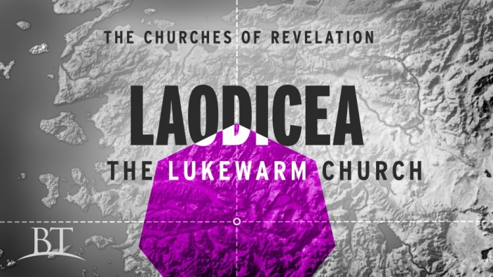
Light the Fire Again!
Revelation 3:14-22
1. Commission v14
- The Background of the Ancient City of Laodicea
- Status Today
2. Condemnation v15-17
- You are Lukewarm
- The Danger of Comfort
- It was a Comfortable church but also a Compromising church
- The Danger of Complacency
- Lukewarmness is often caused by Apathy and Indifference
- The Problem is Widespread
- Jesus prefers a Rejection of faith to Half-hearted living
- You are Wretched
- They thought they were doing Great, but Jesus saw a Difference! He said they were pitiful, poor, blind and naked
- Laodicea was Dying and did not even Know it
3. Correction v18-19
- Buy Gold from Me
- You think you are Wealthy but you are Poor
- Buy White clothes to wear
- You think you have rich Clothes but you are Naked
- Buy Salve for your eyes
- You think you can See but you are Blind
4. A Word of Hope v20
- This offer applies to Christians
- Jesus desires to be in Relationship with you
Honolulu AG 7 Letters to your Church November 8, 2020

