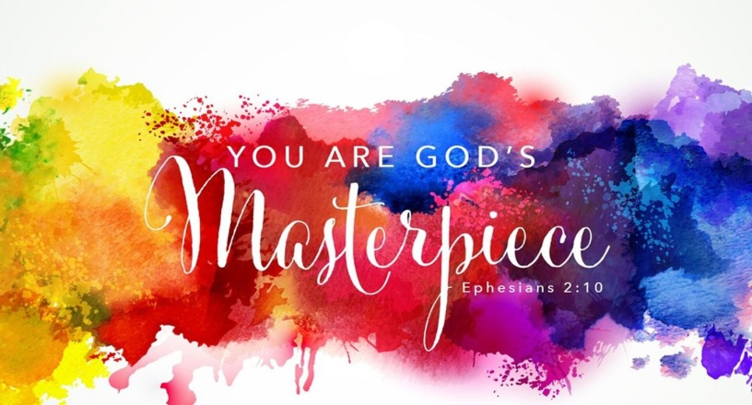
Ephesians 2:10
A. A Masterpiece of Creation; Genesis 2:7
- God is the Master of Creation
- Man is the Pinnacle of God’s Creation; Psalm 8
- God Fashioned Man with His hands; Psalm 139
- It speaks of Intricacy and Intimacy
B. A Masterpiece of Regeneration; Isaiah 43:21
- God not only Created you, He also Redeemed you
- The redeemed person is God’s Poetry
- We are His Masterpiece, due entirely to His Grace
- Because we are His Masterpiece, we are Designed to do His Good Works
C. How should we Respond?
- Trust the Master Artist
  - It is imperative for us to have Confidence in the Master Artist
  - It will give us Patience and Perseverance when the work seems long and the process is difficult
  - The Master Artist uses many Tools to shape you
- Submit to the Master Artist
  - The Master Artist has a Plan for your life
  - The Master Artist has a Purpose for your life
  - The Master Artist has a Reward for your life
  - In the ages to come, He will reveal the Inexpressible riches of His Grace, expressed in His Kindness to us
Honolulu Assembly of God July 17, 2022

