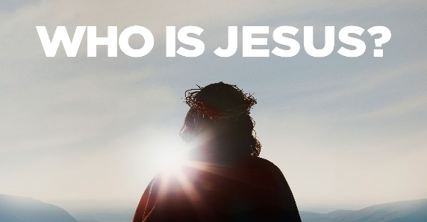
Jesus is Liberator! John 8:31-36

1. You were Slaves to Sin and Satan; Genesis 3
- Everyone is Born in slavery to sin
- Adam and Eve wanted Freedom but instead became Slaves
- People are Deceived and try to find their own Solution
- Counseling
- Education
- Escape

2. Only Jesus can Set you Free; Romans 8:1-2
- He carried your sin and shame when He hung on the Cross
- He took the terrible weight from you that you could not Carry
- You are not just pardoned but are Forgiven and Free
- You have been set Free from Captivity, Sin, Shame, and Hopelessness

3. Now What?
- Live in Freedom
- Proclaim Freedom
- Enjoy Freedom
- Do not Lose your Freedom. Do not let your enemy Enslave you again; Galatians 5:1, 13

What is your Response?
By the precious blood of Jesus, I declare my freedom from:
Anger, Defeat, Depression, Discouragement, Doubt, Envy
Fear, Greed, Hatred, Impatience, Lust, Materialism, Rebellion
Sexual Immorality, Substance Abuse, Unclean talk, Unkindness
Satan & anything he would do to destroy my life or steal my joy!
Honolulu Assembly of God April 21, 2024

My Emancipation Proclamation
I am free from Failure, for “I can do all things
through Christ who strengthens me” Philippians 4:13.
I am free from Want, for “My God shall supply all my needs
according to His riches in glory by Christ Jesus” Philippians 4:19.
I am free from Fear, for “God has not given us a spirit of fear,
but of power, and of love, and of a sound mind” 2 Timothy 1:7.
I am free from Doubt, for “God has given to every man
the measure of faith” Romans 12:3.
I am free from Weakness,
for “The Lord is the strength of my life” Psalm 27:1.
I am free from the Power of Satan, for “Greater is
He that is in me than he that is in the world” 1 John 4:4.
I am free from Defeat, for “God always leads us
in triumphal procession in Christ” 2 Corinthians 2:14.
I am free from Ignorance, for “Christ Jesus
has become for us wisdom from God” 1 Corinthians 1:30.
I am free from the Curse of Sin, for “the blood of Jesus,
His Son, purifies us from all sin” 1 John 1:7.
I am free from Worry, for I can
“Cast all (my) cares upon Him, for He cares for (me)” 1 Peter 5:7.
I am free from Bondage, for “Where the Spirit of the Lord is,
there is freedom” 2 Corinthians 3:17.
I am free from Condemnation, for “There is therefore now
no condemnation to them which are in Christ Jesus,
who walk not after the flesh, but after the Spirit” Romans 8:1.

