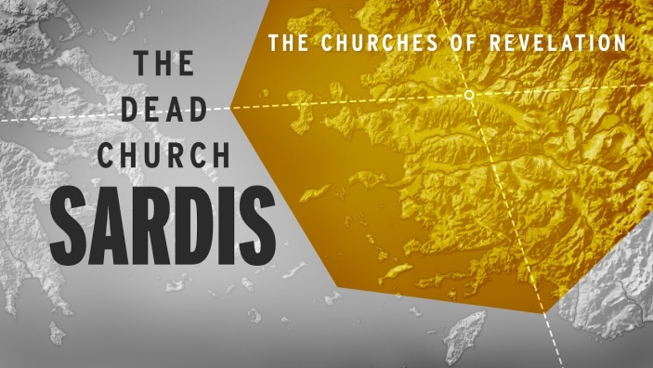
The Church of the Living Dead!
Revelation 3:1-6
1. Commission v1
- The Background of the Ancient City of Sardis
- Status Today
2. Condemnation v1
- You have a Reputation for being Alive
- They had a Reputation but no Reality
- They had grown Comfortable and become Content
- But the Reality is you are Dead
- They had Activity but no Power, Good works but no Relationship with Jesus
- They once had a great Impact in their city, but now Nothing is happening
3. Correction v2-3
- Jesus’ warning to Sardis and the Church Today: Wake Up!
- Don’t fall Asleep! Don’t become Complacent!
- Jesus will come like a Thief in the night so be Ready!
- Strengthen what remains
- Their Actions were right but their Motives were wrong
4. Characteristics of a “Living Dead” Church
- Living in the Past
- They have a great History but little in the Present
- The value we place on Tradition is more important than our love for Christ
- We live life looking through the rear-view Mirror
- Living with an anemic Prayer Life
- We are not Empowered by the Holy Spirit
Honolulu AG 7 Letters to your Church November 1, 2020

