John 14:12
A. Caleb trusted God when Everyone and Everything else said, “It is Impossible!”
- The problem with Man’s Viewpoint; Numbers 13:27-33
- It is a land of Milk and Honey but it Cannot be done
- Caleb had a Different viewpoint; Who is Bigger?
- He was All In! He was ready to Step Out
- Result? He received a Promise; Numbers 14:24
B. He went after the Biggest Challenge when it would have been tempting to just Coast; Joshua 14:6-15
- He refused to let Age keep him from his inheritance
- God helped me Before and He will help me Now
- He refused to let Missed Opportunity keep him from his inheritance
- He suffered because of Other People’s bad decisions and could have become Bitter
- At 85 years old Caleb was as full of Faith and Courage as 45 years earlier
- He refused to let Adversity keep him from his inheritance
- He refused to let Doubt and lack of Faith keep him from his inheritance
- He refused to try to get by with the Minimum
- He chose to Hold Onto God’s promise
C. What about You?
- Don’t let Fear limit what you can Accomplish
- Don’t stay Safe in your Comfort Zone
- Don’t be afraid of Risk or Failing
- Don’t let your Circumstances determine your Outcome
- Get a Bigger Picture of who God is
Honolulu Assembly of God January 2, 2022
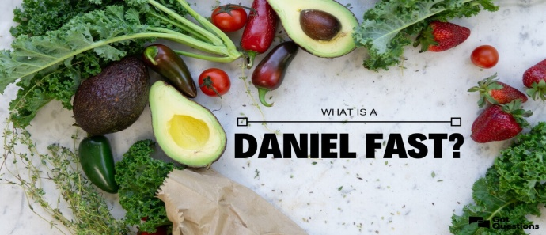
Foods to Eat on the Daniel Fast
- All fruit – fresh, frozen, dried, juiced, or canned.
- All vegetables – fresh, frozen, dried, juiced, or canned.
- All whole grains – whole wheat, brown rice, millet, quinoa, oats, barley, grits, whole wheat pasta, whole wheat tortillas, rice cakes and popcorn.
- All nuts & seeds – almonds, cashews, macadamia nuts, peanuts, pecans, pine nuts, walnuts, pumpkin seeds, sesame seeds, and sunflower seeds; unsweetened almond milk. Nut butters are also included.
- All legumes - canned or dried; black beans, black eyed peas, cannellini beans, garbanzo beans (chickpeas), great northern beans, kidney beans, lentils, pinto beans, and split peas.
- All quality oils – canola, coconut, grape seed, olive, peanut, and sesame.
- Beverages – distilled water, filtered water, and spring water.
- Other – unsweetened almond milk, rice milk, or soy milk; herbs, spices, salt, pepper, seasonings, soy products, and tofu.
Foods to Avoid on the Daniel Fast
- All meat & animal products – beef, fish, lamb, poultry, and pork.
- All dairy products – butter, cheese, cream, eggs, and milk.
- All sweeteners – agave nectar, artificial sweeteners, cane juice, honey, molasses, raw sugar, syrups, stevia, and sugar.
- All leavened bread & yeast – baked goods and Ezekiel bread
(if it contains yeast and honey).
- All refined & processed food products – artificial flavorings, chemicals, food additives, preservatives, white flour, white rice.
- All deep-fried foods – corn chips, French fries, potato chips.
- All solid fats – lard, margarine, shortening and foods high in fat.
- Beverages –carbonated drinks, coffee, energy drinks, herbal tea, and tea.
Special Note: If you have health issues, please be sure to contact your health professional for advice before committing to any fast including the Daniel Fast.
Source: https://danielfast.wordpress.com/daniel-fast-food-list/

