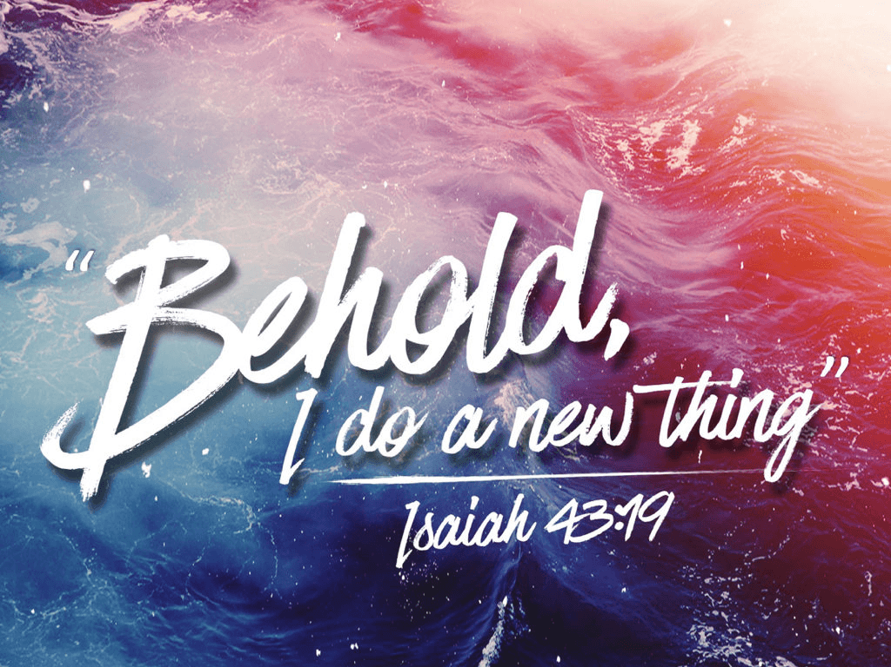
Line up with what the Bible _______ about you and your purpose.
Make your Decisions in life based upon that ___________________.
1. New __________ (2 Corinthians 5:17; 1 Corinthians 6:9-11)
- You are not the ___________ person you used to be
- You have been ___________ _____________
- You must therefore _________ ________ of your New Life
- Put ________ your Old Life; Ephesians 4:25-31
- Put _______ your New Life; Ephesians 4:20-24
2. New ___________ (Romans 12:1-2; Colossians 3:1-3)
- Put ________ your Old Mind
- Make the Choice to _____________ the Lord by ________________ you Say and Do
- Put _______ your New Mind; Philippians 4:8
- Don’t input _________; input __________ and ___________
3. New _________ (Psalm 40:1-3)
- ______________ in Him and give Him all the ___________
- The ________________ of Praising the Lord
- God is _______________
- He _____________ your worship; He _____________ your worship; He ____________ your worship
- We are _____________
- Fear is ______________; Faith is ________________
- Power is _______________
- Others come to ___________ in Jesus when they see your Life
Honolulu Assembly of God January 4, 2026
Line up with what the Bible _______ about you and your purpose.
Make your Decisions in life based upon that ___________________.
1. New __________ (2 Corinthians 5:17; 1 Corinthians 6:9-11)
- You are not the ___________ person you used to be
- You have been ___________ _____________
- You must therefore _________ ________ of your New Life
- Put ________ your Old Life; Ephesians 4:25-31
- Put _______ your New Life; Ephesians 4:20-24
2. New ___________ (Romans 12:1-2; Colossians 3:1-3)
- Put ________ your Old Mind
- Make the Choice to _____________ the Lord by ________________ you Say and Do
- Put _______ your New Mind; Philippians 4:8
- Don’t input _________; input __________ and ___________
3. New _________ (Psalm 40:1-3)
- ______________ in Him and give Him all the ___________
- The ________________ of Praising the Lord
- God is _______________
- He _____________ your worship; He _____________ your worship; He ____________ your worship
- We are _____________
- Fear is ______________; Faith is ________________
- Power is _______________
- Others come to ___________ in Jesus when they see your Life
Honolulu Assembly of God January 4, 2026
