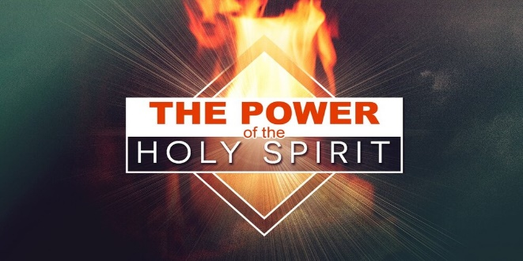
Acts 1:4-5, 8; 2:1-4
Why do we need the Holy Spirit’s Empowering?
1. Signs and Wonders; John 14:12
- Miracles are not the End result; Power is not just for Healing
- Miracles create an Environment for the communication of the Gospel; Acts 13:6-12
- God Intervenes, Jesus is Exalted, and lives can be Transformed by the power of the Holy Spirit
2. Prayer and Intercession; Romans 8:26-27
- Have you ever wondered What or How to pray?
- When you don’t know what to pray in English, pray in a Heavenly language
- It is a Secret language between you and God
- This is your Privilege as Sons and Daughters of the Lord
3. Live an Overcoming Christian life; Romans 8:11-17
- When the Holy Spirit’s power is at work in your life, He can either Remove the desire for sin or give you the ability to Overcome the temptation
- Ever felt Flat spiritually? Get Plugged In to the Spirit’s power
- You need His overcoming Empowering work in your life
4. Witnessing; Acts 1:8
- The disciples were Transformed by empowering of Spirit
- The Holy Spirit will fall on you and Clothe you with power
- God knows your Personality and can use it for His Glory
- He desires to take you from where you Are to where He wants you to Be
Honolulu Assembly of God June 11, 2023

