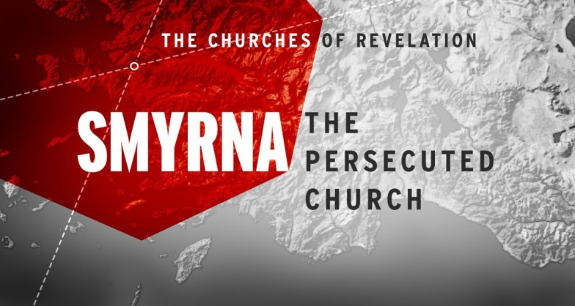
Take Heart!
Revelation 2:8-11
1. Commission v8
- The Background of the Ancient City of Smyrna
- Status Today
- History of the Church
2. Commendation v9-10
- I know your Affliction and Poverty
- Affliction = Crushing; poverty = Destitution
- But you are Rich
- Although the Christians in Smyrna were Lacking in the eyes of the world, in God’s eyes they had Everything
- Their Poverty was replaced by the true Riches of Christ
- How much better is it to be Poor in the eyes of the world but Rich before Christ?
- The Value of Spiritual Riches
- Don’t just work for that which will last for Now, but labor for that which will last for all Eternity
3. Command v10-11
- Be Faithful unto Death
- Reward: You will Receive a Crown of Life
4. Takeaways
- Suffering often comes to the people of God
- True Wealth can only be measured by how Long it lasts
- Faith, not Fear, is the proper response to Adversity
- Death does not have the Final answer; Jesus does!
Honolulu AG 7 Letters to your Church October 11, 2020

