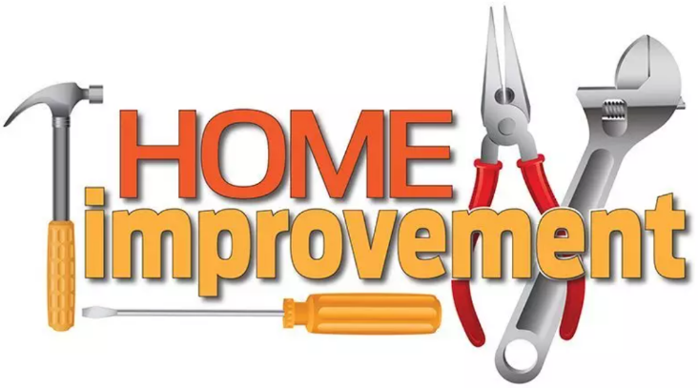
Build a Home of Grace!
Ephesians 4:25-5:2
A. (The Apostle Paul’s Instruction) Put Off and Put On
- Put off Falsehood v25
- Trust is easy to Break but very hard to Restore
- Put off Anger v26-27
- Anger gives the devil a Foothold in your life
- Put off Laziness v28
- The purpose for Getting becomes Giving
- Put off Unwholesome Talk v29
- Do you speak the truth in Love? or in Judgment?
- Put on Blessing Words v29-32
- Your words should Taste Good to those who receive them
- Be Imitators of God 5:1-2
- You are no longer the person you Used to be
B. Practical Application
- Your Marriage
- Your Children
- Your Friendships
C. Action Steps for this Week
- Bless people
- Don’t assume the Worst
- Do give others the Benefit of the doubt
- Do treat them like You would want to be treated
Honolulu Assembly of God Home Improvement! April 12, 2026

