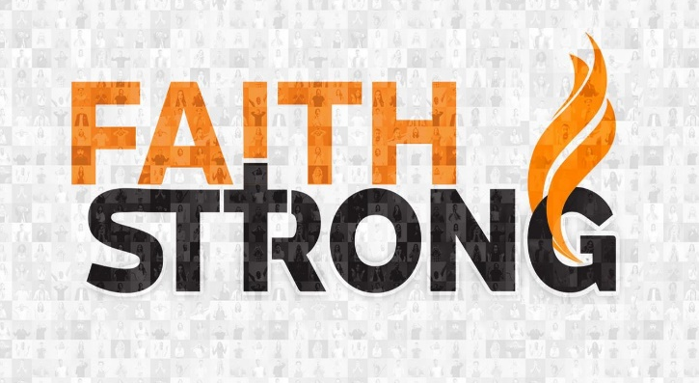
Step Out of the Boat! Matthew 14:22-33

A. The Example: Peter’s Ups and Downs
- Peter’s Character
- Very Outspoken, but he comes through in the Clutch
- Peter’s Mistake
- He got his eyes off Jesus and on the Wind and Waves
- Peter’s Faith
- He had a Vision: to believe Jesus to do the Impossible

B. The Obstacles: What Keeps us in the Boat?
- Fears
- Fear is the Opposite of Faith
- Doubts
- How can you trust God if you are Uncertain it is Him?
- Securities
- Fear and doubt lead to a strong desire for Security
- It’s the Safety of the boat: Windy and wet but still “Secure”

C. The Challenge: Step Out of the Boat!
- Leave your Fears, Doubts, and Securities behind
- Be willing to take a Risk and get out of the boat
- Look to Jesus
- Don’t look at the Wind and Waves; keep looking at Jesus
- Just Do it!
- Don’t stay Huddled with the rest in the Back of the boat
- Attempt something so Great for God that it is bound for Failure if He does not Intervene
Next Step: In what ways do you need to Step Out of the Boat this week?
Honolulu Assembly of God Faith Strong! September 17, 2023

