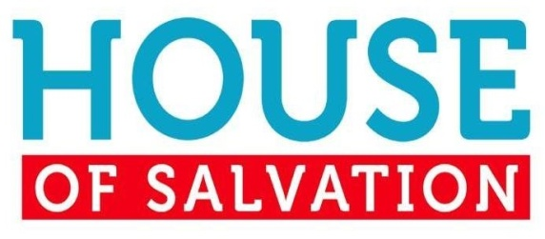
2 Corinthians 5:14-21
1. You can have Redemption from Sin
- We were all born in Sin and Rebellion against God
- The penalty is Death, both physical and spiritual
- Jesus Christ came to purchase our Redemption; Romans 5:6-8
- He was the perfect Sacrifice; His blood paid the Price
2. You can have Hope for Today
- We have been set free from Captivity to Sin
- Before, there was no Hope
- Now, we have been set Free from the bondage of sin and death
- We have been set free from the Guilt of Sin
- There is therefore now no Condemnation; Romans 8:1
- Jesus says to you: You are Pardoned! You are Mine!
3. You can have Joy for All Eternity
- We will See Jesus face to face
- What would you say to the one who Paid the ransom for you?
- Would you Bow Down and Worship Him?
- The Grave is not the end!
- There will be a great Reunion with those who have gone ahead
- What a Celebration we will have in Heaven; Revelation 19:6-7
4. We must Share the Good News of Salvation with Others
- Jesus has given us the Ministry of Reconciliation; 2 Corinthians 5:14-19
- The Father wants All Mankind brought to Himself
- He is not willing that Any should perish
- God has called us to be Ambassadors for Christ; 2 Corinthians 5:20-21
- We are Partners with Jesus Christ in this great ministry
- Our message to All: Be Reconciled to God!
Honolulu Assembly of God Welcome to the House January 15, 2023

