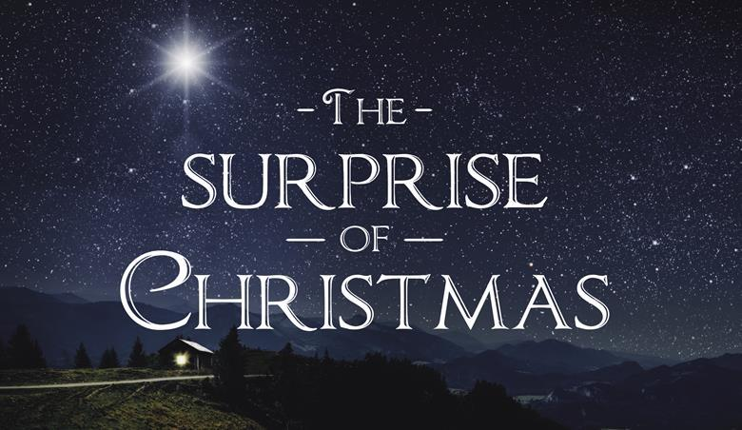
Luke 2:1-20
A. Surprises Then
- Mary
- Joseph
- Shepherds
- Wise Men
- Religious Leaders
- King Herod
- Satan
- God Most High laid aside power and glory to become a Man
- Greatest Surprise of All
- The Son of God was willing to Humble Himself and Die on a Cross
- Second Greatest Surprise
- Jesus is willing to humble Himself to live in Your heart
B. Surprises Today
- Jesus is Still surprising us today
- Why does Jesus surprise us?
  - To show us He is completely in Charge
  - To make us come to Him on His Terms
  - To show us we must come to Him by Faith
- Question: Is Jesus still surprising You today?
  - How Big is your God?
  - Is He beyond your Comprehension?
  - Or have you settled into the Comfort Zone?
Honolulu Assembly of God Christmastime December 7, 2025
Christmas means
He descended that we might ascend
(John 6:38; 14:3)
He became poor that we might become rich
(2 Corinthians 8:9; James 2:5).
He was born that we might be born again
(John 1:14; 3:2, 7).
He became a servant that we might become sons and daughters
(Philippians 2:7; Galatians 4:6-7).
He had no home that we might have a home in heaven
(Matthew 8:20; John 14:2).
He was hungry that we might be fed
(Matthew 4:2; John 6:50).
He was thirsty that we might be satisfied
(John 19:26).
He was stripped that we might be clothed
(Matthew 27:28; Galatians 3:27).
He was forsaken that we might be restored
(Matthew 27:26; 28:20).
He was sad that we might become glad
(Isaiah 53:3; Philippians 4:4).
He was bound that we might be set free
(Matthew 27:2; John 8:32-36).
He was made sin that we might be made righteous
(2 Corinthians 5:21).
He died that we might live
(John 5:24-25).
He came down that we might be caught up
(1 Thessalonians 4:16-17).
