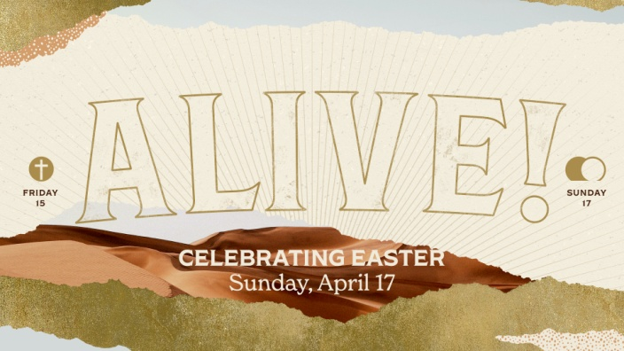
1 Corinthians 15:20-26, 50-57
A. Death’s Reign
- Death’s Dominion
- Because Sin reigned, Death reigned
- Death reigned Supreme from the beginning of Time
- Death’s Origin; Genesis 3
- Adam and Eve’s sin brought disastrous Consequences
- Death’s reign had just Begun; cf, Genesis 5
B. Death’s Death
- Death’s plan for ultimate Victory: the Cross
- The Promised Savior would Come and take away Death’s Rule
- But Death did not Want to give up his Throne
- His Plan was Perfect; it looked Foolproof
- But the Cross was Not the End
- What Death thought would bring him Total Triumph instead became the instrument of his own Total Defeat
- Death wanted Victory but instead was completely Vanquished
- God is in the work of taking Tragedy and turning it into Triumph
- When Jesus cried, “It is Finished!”, it was not end of His Life but the end of Death
C. Christ’s Reign
- Spiritual: We are restored to the Father
- Physical: We shall Rise from the grave; Hebrews 2:14-15
- Eternal: We shall be at home in heaven with Jesus for all Eternity
Honolulu Assembly of God Resurrection Sunday April 17, 2022

