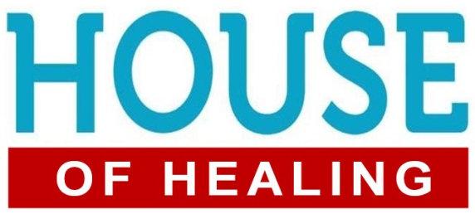
James 5:13-16; John 5:1-9
1. Then: A Miraculous Healing
- A Sick Man; v1-5
- He was in a Wretched condition: Not able to walk for 38 years
- A Marvelous Intervention; v8-9a
- Jesus freely gave him Everything he needed
- A Profound Question: “Do you Want to get well?” v6
- The man was wretched not only in regards to his Physical condition but also his Attitude; v7
- He was full of Excuses
- I can’t Get in the water to be healed
- No one is willing to Help me
- Others get in the water First and receive the miracle
- It’s not my Fault; I’m a Victim
- Some people become Used to their situation and do not want to Change
- Others want to Blame someone else
2. Today: A House of Healing
- Physical Healing
- We want to have a Reputation as a House of Healing, so pray the prayer of Faith; James 5
- Emotional Healing
- Only Jesus can heal your Broken heart
- Financial Healing
- Don’t look to Man; trust in God for what you need
- Relationship Healing
- Relationships that are Ruined can be Restored
- Spiritual Healing
- Physical healing is Temporary but Spiritual healing is Eternal
Honolulu Assembly of God Welcome to the House January 29, 2023

