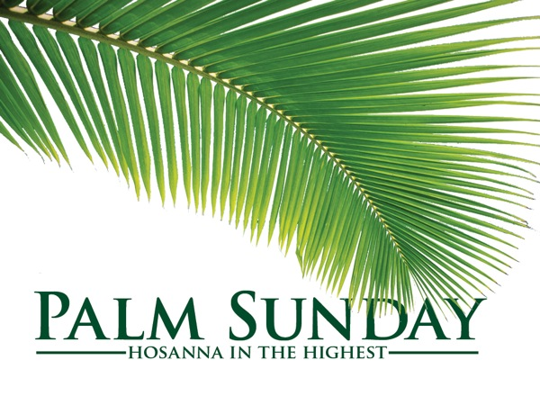
Matthew 21:1-11
Who’s in the Driver’s Seat?

The journey in life is from the Passenger seat to the Driver’s seat
A. Whoever is in the Driver’s seat is the one in Control
- It’s a big moment in your life when you hand someone else the Keys
- You may find Jesus handy as long as He is in the Passenger seat
- But We want to Stay in the Driver’s seat
B. Who is in the Driver’s seat in Your life?
- Is it You or Jesus?
- Is Jesus in the car but just along for the Ride?
- What is Surrender? There is a God and it’s not Me
- Isaiah 55:8-9; Everything God has and does is Higher, Better, Wiser
C. Surrendering to Jesus is not Easy but it leads to Freedom, Life, and Fulfillment
- The Gospel is not just about Love; it’s also about Lordship
- God loves you just the way you Are, but He loves you too much to let you Stay that way
D. You must surrender Control Daily
- Life works better when Jesus is in the Driver’s seat
- What is the problem with a Living sacrifice? It keeps Crawling off the altar
Apply it: You have 3 options for your Heart
- Live with a Rebellious heart
- Live with a Divided heart
- Live with a Surrendered heart
Honolulu Assembly of God Palm Sunday 2024
Who’s in the Driver’s Seat?

