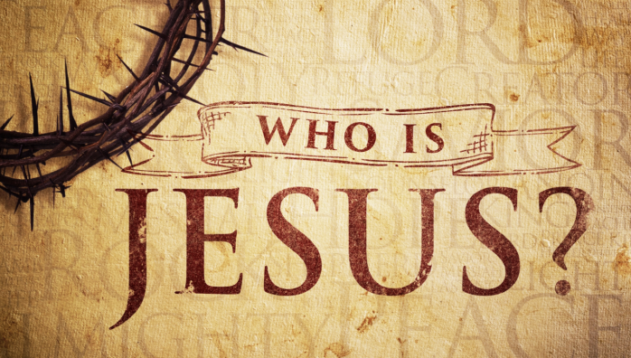
Matthew 16:13-16; 17:1-8
A. Peter’s Great Confession
- A Probing Question:
Who do You say I am? v13-15
- A Passionate Declaration:
You are the Christ v16
- A Foundational Truth for us today:
Jesus is God!
B. A Miracle Transfiguration
- A Terrifying Transformation
Matthew 17:1-3
- A Terrified Man v4
- An Unmistakable Verdict v5-6
C. Who do You say Jesus is?
- Is your faith Weak like Peter?
- Are you Trusting in Jesus?
A Rock solid faith?
In response to the question, “Who do you say I am?”, Peter gave the brilliant response, “You are the Messiah, the Son of the living God” (Matthew 16:16). Jesus is God and is bigger than any problem, whether it be coronavirus or cancer, financial or family problems, or anything else. Put your trust in Him as your Savior and Lord. And stand strong like a rock!
Honolulu Assembly of God March 22, 2020

