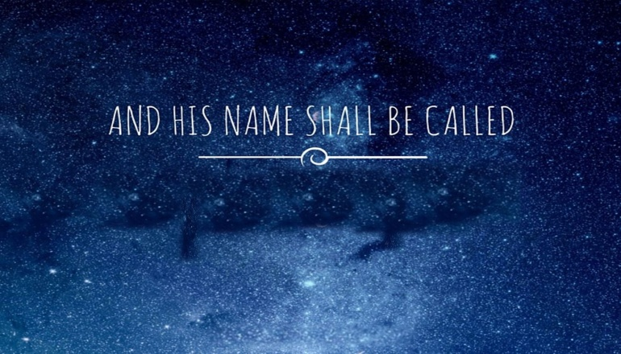
Everlasting Father
Isaiah 9:6
A. Who is He?
- He is Everlasting
- He has Always been
- He is Constant
- He is Father
- He is the Father of Eternity
- He is the exact Representation of the Father
Colossians 1:15-19; John 1:18; Hebrews 1:1-3; John 14:9
- He embodies the Qualities of the Father
B. What did He do?
- Immanuel; Isaiah 7:14
- Incarnation; John 1:14; Philippians 2:6-11
- Involvement
C. Why did He do it?
- His Deity Demanded it; John 3:16; 1 John 3:16
- Our Sin Required it; Romans 3:25-26; 8:1-3
- His Love Fulfilled it
Honolulu AG His Name shall be Called December 20, 2020

