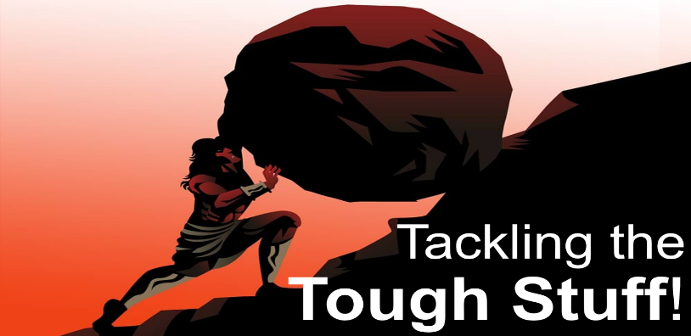
Doubt!
Up or Out?
John 20:24-29
Unbelief is when people Willfully set themselves against biblical teaching.
Doubt is when we have a Barrier that stands in the way of Faith. We Want to believe, but we need Help to believe; Mark 9:14-27.
A. Everyone experiences Doubt at one time or another
- It is OK to have Doubts, but it is not OK to have Doubts All the time
- Don’t Stay in the place of Doubt; Keep going – Straight ahead!
B. Doubts are exaggerated by Isolation
- Doubts grow when you are Alone
- Key: Don’t miss out on your Opportunities
- Don’t try to go it alone when you are Struggling with Doubt
C. Doubt can be a Positive experience
- Jesus made a special Appearance to satisfy Thomas’ demands
- Jesus was willing to Accommodate Thomas’ doubts
- Thomas moved past Honest doubt to Strong faith
D. The Reality of Jesus will Overcome any and every Doubt
- Thomas demanded Elaborate proof but, when he saw Jesus, did he still need Proof? No!
- When struggling with Doubt, seek a fresh Revelation of Jesus
Thought for Week: Don’t doubt in the dark what God has revealed in the light.
Action Steps: Admit you have doubts. Act on your Faith, not on your Doubts.
Don’t isolate yourself. Doubts grow when you are alone.
Praise your way to Confidence. Declaring God’s greatness builds your Faith.
Stand on the Promises of God. Don’t doubt your beliefs and believe your doubts. Your faith is not based on how you feel but on what you know.
Honolulu Assembly of God Tackling the Tough Stuff September 21, 2025

