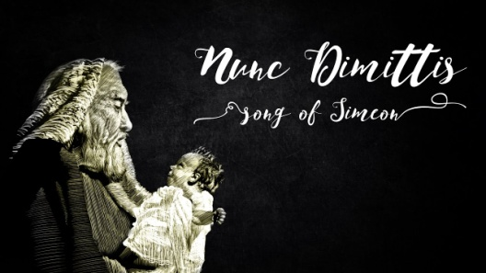
Luke 2:21-35
A. Song Setting v21-24
- At the Temple in Jerusalem on the 8th day for Circumcision
- Offer sacrifices: a Lamb or two Doves
- One bird for the Burnt offering and the other for the Sin offering
B. Simeon’s Story v25-28
- His character: Righteous and Devout
- He was waiting for the Consolation of Israel
- His action: Moved by the Spirit, he went into the Temple Courts
- Many parents were there with 8 day old baby Boys
- If we had been there, we may not even have Known what was happening; There was Nothing to indicate they were special
- It was all so Ordinary yet so Extra-ordinary; so Natural yet so Super-natural
- Somehow, led by the Spirit, Simeon comes to the Right family
C. Simeon’s Song v29-32
- Sovereign Lord v29a
- He declares the Greatness of God; Praise fills his heart
- You now Dismiss your servant v29b
- His mission has been Accomplished
- Instead of Darkness, he sees the Brilliance of true Light: Christ
- What does he see? My eyes have seen Your Salvation v30
- He saw Salvation for All Mankind
- Which you have Prepared in the sight of All people v31-32
- He saw “a Light for revelation to the Gentiles”
1. Let your ordinary life be Transformed by this extraordinary Christ
2. In the midst of darkness, God Always has a light; Be that Light!
Honolulu Assembly of God The Songs of Christmas December 26, 2021

