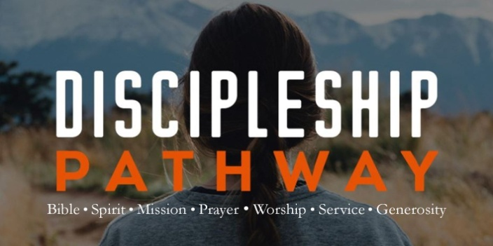
A. The Bible is the Word of God
- It is not the work of Man; 2 Peter 1:20-21
- 66 books were written by 40 different authors over a period of 1500 years in 3 different languages on 3 different continents
- It is the Answer to Life
- How do we know Truth? Via Science, Philosophy or Revelation?
- It is Powerful; Luke 4:1-13, 14
- Let the Word of God Transform your life
B. The Bible is Relevant for Today
- It is not the Dusty work of ancient man
- The Bible is Accurate about All it records
- The Bible is the Key to your Best Life
C. The Bible is our Final Authority
- Our Final Authority is not the Opinion of Man
- Man’s thoughts and opinions are Imperfect
- Only God’s Word will last Forever; Isaiah 55:11
- His Word is Unchanging; Matthew 24:35
- It keeps us from the Deception of our spiritual Enemy; John 8:32
- You can know what is False when you know what is True
D. Application: What I do Now?
- Read it
- Make time for the Word; it is a Spiritual battle
- Read and Meditate on the Word; Psalm 119:11
- Apply it
- God’s Word is not given to us for our Information but for our Transformation
Honolulu Assembly of God Discipleship Pathway February 20, 2022

