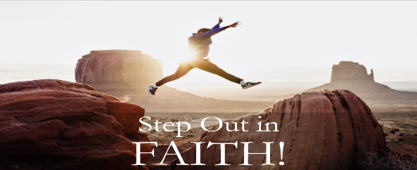
Joshua: Faith to Possess the Land!
Joshua 1:6-9
Faith is obeying God in spite of Feelings, Circumstances, or Consequences.
Walk by Faith, not by Sight!
A. Be Strong and Courageous v6-7a
- There are Battles to fight and win
- It is not for the Fainthearted
- There are Giants to conquer
- God has called you to Go Forth in Victory
- You cannot walk in Fear and Discouragement
- Great Courage comes from great Faith
- Recognize that Nothing will happen to you that is too Big for God
B. Live God’s Word v7b-8
- The Word builds Faith in your heart
- If you are Not living in the Word, you will wither and Die
- You cannot just Survive; you must be an Overcomer – more than a Conqueror
- Don’t live Beneath your birthright and calling
C. God is With you Wherever you go v9
- Joshua was given this Assurance: “As I was with Moses, so I will be with you” v5
- Success come from God’s Presence
- Everywhere you go, Jesus Christ is With you; Everything you do, He will Empower you
Honolulu Assembly of God Step Out in Faith! February 8, 2026

