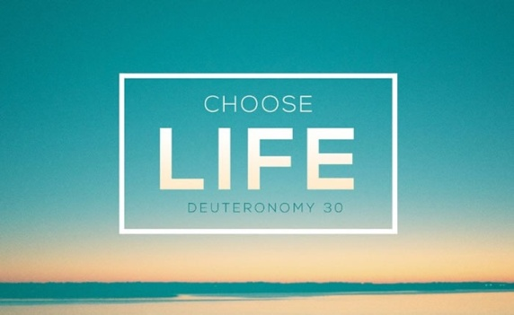
Deuteronomy 30:19-20
A. What does it Say? Choose Life!
- Having (v1-16)
- God gives His people Precisely what we need and these things last as long as we Need them
- Losing (v17-18)
- A sure way to lose what you have is to make it the Object of your Desire: an Idol
- Having (v19-20)
- God gives you the Choice: either Accept or Reject
B. What does it Mean?
- Be Hot for Christ
- Don’t be Lukewarm
- Be either Hot or Cold
- Be on Fire for the Lord
- Don’t be Passive or Non-Committal, sitting on the Fence
- Are you Stepping out in Faith for Jesus Christ? Are you Speaking out?
- Our tendency is toward Stagnation
- Some Christians only have a Title; they are “Christian”
in Name only
- Stir up the Flame
- Keep your spiritual Fervor; Romans 12:11
- Impact Others for Christ
- Salvation and greater Commitment
- Look Past the Outside
Honolulu Assembly of God Choices! July 18, 2021

