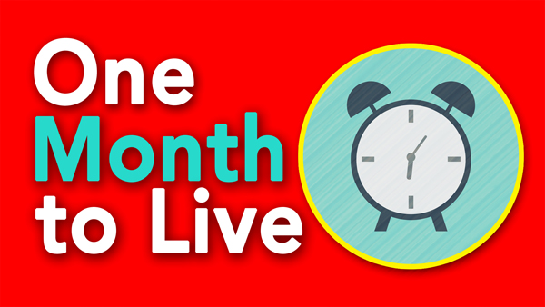
Live a ‘No Regrets’ Life!
John 10:10
A. Love; 1 Corinthians 13
- Love is the Foundational piece of the Passion puzzle
- Passion is not the same as Lust
- Passion: The more you do something, the More satisfied you are
- Lust: The more you do something, the Less satisfied you are;
Lust leaves you Empty
- They Left their first love; Revelation 2:4-5
- Love is not a feeling; Love is a Decision
- Rekindle your Love for the Lord
B. Integrity; Mark 12:30
- Integrate what I say I believe into daily actions
- Think of your life like a Pie
- God wants to be the Center of all the slices
- He demands First place in your life or No place at all
C. Forgiveness; Ephesians 4:32
- Nothing drains Passion quicker than unresolved Conflict
- Resentment is a great Passion stealer
- Jesus was the most Passionate person who ever lived because He was the most Forgiving person who ever lived
D. Enthusiasm; Colossians 3:23
- Enthusiasm = En Theos = God Within
- You become passionate when you start spending Time with God
- Remember: God is your Boss, so work with all your Heart
Honolulu Assembly of God One Month to Live! July 6, 2025

