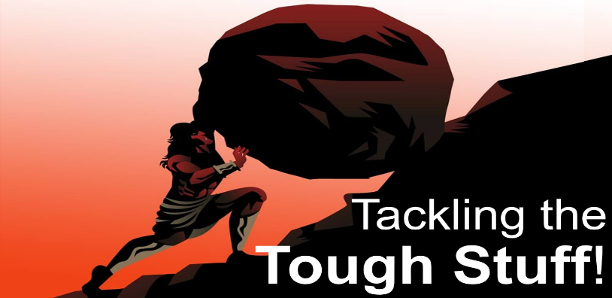
Disappointment!
Handling Life’s 2nd Best
Acts 16:6-10
A. Paul (50AD) Acts 16:6-10
- Paul did not plan to go to Troas
- His desire was to go to Bithynia
- Bithynia was the place of Desire
- Troas was the place of Disappointment
- Paul might even have felt Abandoned and Forgotten in Troas
- The outcome was much Different than Paul could ever imagine
- God had something Greater in store for him
- Question: What do you do while Waiting in your Troas?
B. You (2025AD)
- Recognize that God’s Best is Better than Your Best
- God has a different Definition of Best than we do
- Your Place of Disappointment will reveal your Faith level
- Recognize the Necessity of being Content in Every circumstance
- Where God Guides, He Provides; not just Money but also Grace, Strength, Peace, and more
- Don’t Pity yourself; have a Thankful heart
- Trust the Unseen Hand of God
- We get our eyes on what we Think is best and miss out on what God Knows is Best!
- When you can’t see God’s Hand, trust His Heart
Thought for the Week: “The bumps in life are what you climb on.”
Honolulu Assembly of God Tackling the Tough Stuff September 7, 2025

