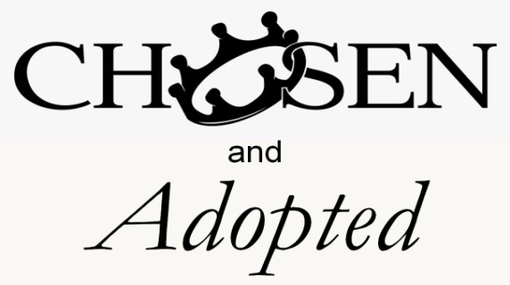
John 15:16; Ephesians 1:4-5
1. You are Chosen
- The Joy of being Chosen
- Everyone wants to be chosen by Someone
- The Incredible Joy of being Chosen by God, the Creator of the Universe
- Creator God Himself has Individually and Specifically chosen you
- Why did God choose you?
- He chose you because He Chose to choose you
- Two confusing questions: Election and Free Will
- How can Election and Free Will be True at the Same time?
- If some people are Chosen, are some Not chosen?
- Application: What does all this Mean?
- Your Value: God don’t make no Junk
- Your Position: There are No Second Class Citizens with God
- Your Security: Your Christian life does not depend upon You
- Your Purpose: You have been created to do Good Works
2. You are Adopted
- The Joy of Physical Adoption
- An Adopted child grows in your Heart, not your Tummy
- The Incredible Joy of Spiritual Adoption
- Jesus Christ not only Redeemed you, He also Adopted you into His Forever Family
- The Two Sides of Spiritual Adoption
- You are Adopted into the Family of God
- You are Adopted into the Fullness of God
Honolulu Assembly of God A Brand New You May 16, 2021

