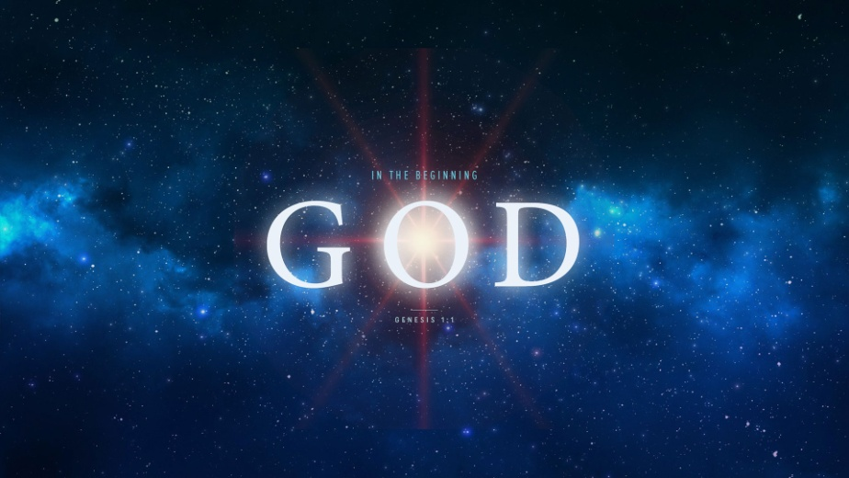
The Consequences of Sin!
Genesis 4:1-16
1. The Birth v1-2
- Adam and Eve no longer lived in the Paradise God made for them
- Their children were born and raised where All families live – Outside of Eden
- Eve hoped Cain would be the promised Deliverer
2. The Offering v3-5
- Cain and Abel knew worship is hollow and empty without Giving so they both brought Offerings
- God looked with Favor on Abel’s offering but He did Not look with favor on Cain’s offering
- To become righteous before God, we need to be Cleansed by the shedding of Blood
3. The Anger v5-8
- Warning: If you do not do what is Right, sin is crouching at your Door
- Will you Master sin? Or will Sin master you?
- The virus of sin Infected the parent’s Children
4. The Consequences v9-16
- Cain’s murderous act had its Beginning in the sin of his Father
- Unlike his father, who admitted his crime, Cain Added to his condemnation by Lying
- God’s Judgment is restrained by His Grace
Honolulu Assembly of God In the Beginning God! August 30, 2018

