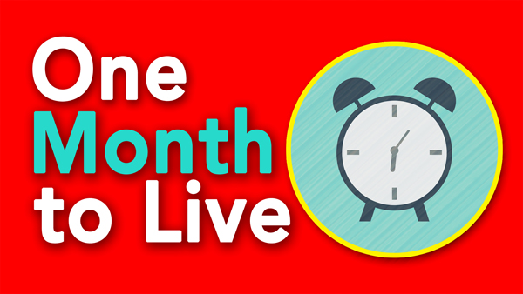
Learn Humbly!
2 Corinthians 12:7-10
A. Learn from your Losses
- No matter who you are, you will Fail at some point
- We must learn from our failures in life in order to be able to Move Ahead
- Jesus sees the Guilt and Regret and Shame that you are trying to hide deep down inside
- Because of the power of the Cross, your failure is not Final
- Take Responsibility for your failures
- When I admit my failures, I get another Chance
- God cannot use you when you are Proud; He doesn’t get the Glory
- Let Go of your Guilt
- The race is not Over for you because He is the God of the Second Chance
- Rest of story: Peter’s Future was better than his Past
D. Surrender to God’s Strength
- When we are Proud, God can’t use us
- When we are Weakest, God is Strongest
- God wants to display His strength through your Weakness
- Challenge: Put your Surrender into Practice every day
Bonus: Three Phases of Learning Humbly
- The Call
- There are no Great people, just Ordinary people who God lifts up to Greatness
- The Wall
- Every day we must come to the place where we confess our Insufficiency
- The Fall
- You have a choice: Either fall on your Face in failure or fall on your Knees in surrender
Honolulu Assembly of God One Month to Live! May 25, 2025

