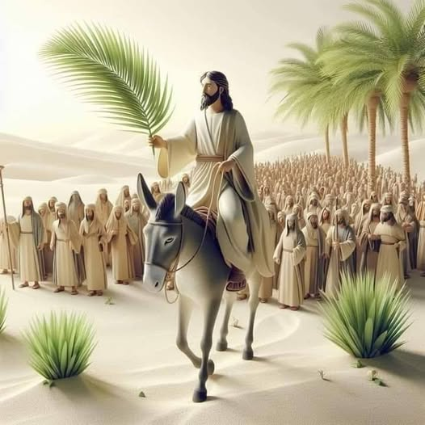
Palm Sunday Praises!
Matthew 21:1-16
1. Worship Jesus Christ as King
- Palm Sunday Then (30AD)
- Fulfillment of Prophecy v1-5
- An Enthusiastic crowd v6-11
- A Hostile reaction v15-16
- Palm Sunday Today (2026)
- A time for Praise and Worship
- A time for Commitment
- Just like the 1st Palm Sunday, today is a Day of Decision
- Will I live my life for Myself? Or will I live my life for Jesus?
2. Serve Jesus Christ as Lord
- He is Supreme Ruler
- He deserves all Power and Authority
- He demands Lordship in every area of your life
- Is Jesus King over Every area of your life?
- He is worthy of all Honor and Glory
- Palm Sunday 30AD was Unfulfilling because people were Fickle
- Jesus will be Glorified or even the Rocks will cry out!
- If you and I don’t praise Him, He will find those who Will
Palm Sunday March 29, 2026 Honolulu Assembly of God

