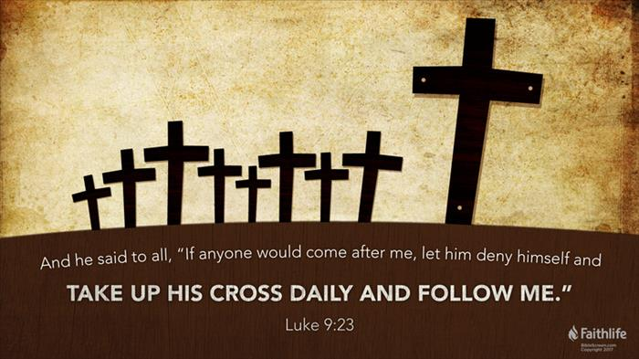
Become a Dead Man on Furlough!
A. The Way of Self
- The Way of Self is the World’s way
- It is to Pamper and Indulge yourself
- Have it Your way; What’s in it for Me?
B. The Way of the Cross
- What is the Cross? Misconceptions
- For many people, the cross is a beautiful piece of Jewelry
- For others, it is the Trials and Burdens of life
- What is the Cross in Luke 9? Death!
- To carry one’s cross was to proceed to the place of Execution
- To Shame and Demoralize prisoners and Frighten spectators
- You are not waiting on Death Row; you are Already dead!
C. The Way of Death
- It is easy to “Try Jesus” and then go on with life as Usual
- Instead, you must realize you are Right Now dead man on furlough
- Lay All your life down at feet of Jesus Christ; Complete Surrender!
- This is Foolishness to the world; Utter Nonsense
- Logic: If you give your life Away, then you have Lost it
- In order to Save your life, you must Hold Onto it
- Jesus turns the World’s Way Upside Down
- To try to Save your life is to Lose it
- But when you Give it away, you will Find it
- Jim Elliott: “He is no Fool who gives up what he cannot Keep to gain what he cannot Lose”
Honolulu Assembly of God Choices! August 29, 2021

