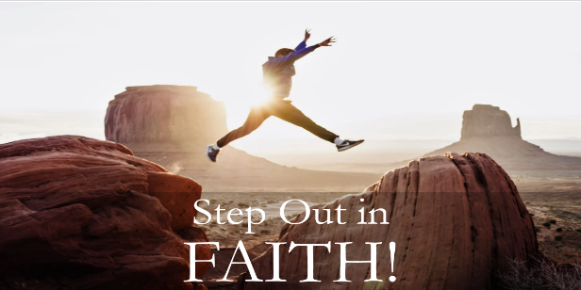
Caleb: Faith to Believe for Greater Things!
Numbers 13:27-33; 14:24; Joshua 14:6-15
A. Caleb trusted God when Everyone and Everything else said, “It is Impossible!”
- The problem with Man’s viewpoint: it is Limited; Numbers 13:27-33
- It is indeed a land of Milk and Honey but it Cannot be done
- Caleb had a Different viewpoint: Who is Bigger?
- He was All In! He was ready to Step Out in faith
- Result? He received a Promise; Numbers 14:24
B. He went after the Biggest Challenge when it would have been tempting to just Coast; Joshua 14:6-15
- He refused to let Age keep him from his inheritance
- God helped me Before and He will help me Now
- He refused to let Missed Opportunity keep him from his inheritance
- He suffered because of Other People’s bad decisions and could have become Bitter
- At 85 years old Caleb was as full of Faith and Courage as 45 years earlier
- He refused to let Adversity keep him from his inheritance
- He refused to let Doubt and lack of Faith keep him from his inheritance
- He refused to try to get by with the Minimum
- He chose to Hold Onto God’s promise
C. What about You?
- Don’t let Fear limit what you can Accomplish
- Don’t stay Safe in your Comfort Zone
- Don’t be afraid of Risk or Failure
- Don’t let your Circumstances determine your Future
- Get a Bigger Picture of who God is
Honolulu Assembly of God February 22, 2026

