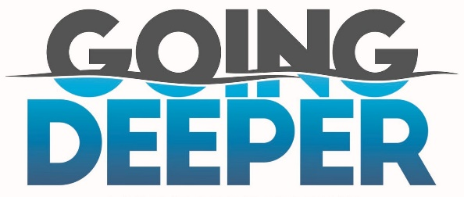
Death & Life = Jesus! 2 Corinthians 4:7-11
A. God’s Great Gift in Us
- We have this Treasure
- In Jars of Clay
- To show the All-Surpassing Power is from God and not from Us
  - Galatians 6:14; Everything in your life should bring Praise and Glory to Jesus
  - Everything that Happens to you is to bring Praise and Glory to Jesus
B. Crushing and Breaking bring Growth
- v8-9 God allows Adversity and Pain to help make you More like Jesus
- Are you a Victim or an Overcomer?
- We are struck down but not Destroyed
- A Knock Down is not necessarily a Defeat
- The Apostle Paul was often Knocked Down but he kept Getting Up
- When you can’t look this way or that way, you can always Look Up
- Why is it so Challenging to live for Jesus? He is Shaping and Molding your life
- Sometimes, the crushing is Jesus Rebuilding you; Jeremiah 18:3-6
- God does not waste Pain! He uses pain to teach you Lessons
C. We carry in our body the Death of Jesus so that His Life might be Revealed in us
- We usually want to live a life of Ease
- We want every prayer Answered in the Way we want it answered and When we want it answered
- Going Deeper means Surrender; submit to the Crushing
- When you allow the Dying of Jesus in your life, you make room for the Life of Jesus in your life
Honolulu Assembly of God Going Deeper! February 25, 2024

