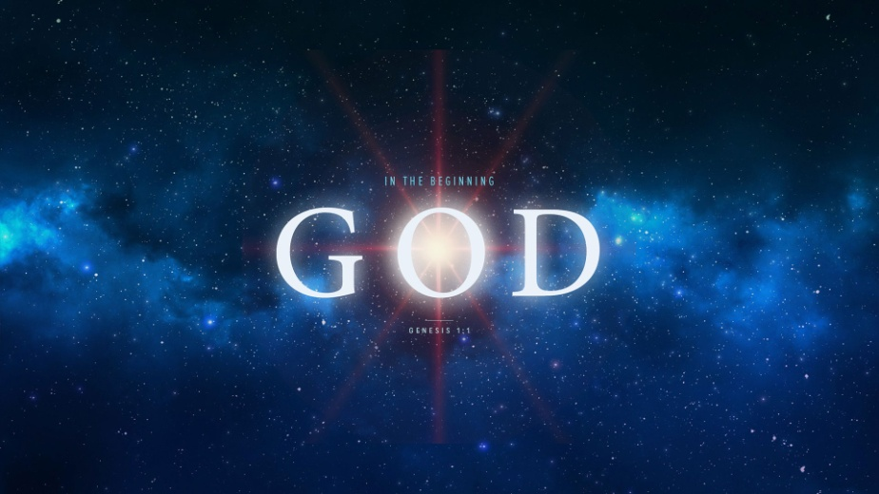
The Mystery of Marriage
Genesis 2:23-24
1. Leave
- Physically
- Leave father and mother and form a New family
- Emotionally
- Your home is where your Spouse is
2. Cleave
Not to divide or split but to adhere firmly and closely, cling
- Be United to One Another
- God plans to Super Glue husband & wife together
- What God has joined together, let no one Separate
- Do not Break the union God has given you
- After you Cleave, you do not Leave
- You will find out it is not Worth the price you paid
3. Become One Flesh
- Commitment
- Marriage is not based on Feelings but on Choices
- Covenant
- When you marry, you make your Vow before God
- Intimacy
- God’s Plan: Grow together Spiritually, Emotionally, then Physically
- Don’t start your relationship Backwards
Honolulu Assembly of God In the Beginning God! August 9, 2018

