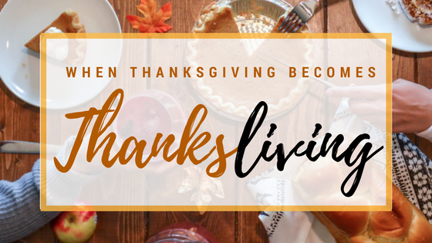
Ephesians 5:20; 1 Thessalonians 5:18
A. Thanks-Living is my Recognition of Who God is and What He has done
- What has He done? He has Blessed me
- Who is He? He is Lord!
B. Thanks-Living is Not based upon the Amount of God’s Provision
- It is tempting to Equate God and His Goodness with the amount of His Giving
- Do you have Much thankfulness for Much?
- How thankful are you for Little?
- Can you be thankful at All times? For All things?
- Antidote to Bitterness? A Thankful heart
- Let your Thankful heart be the Filter that cleanses away the Debris of Bitterness
- If you can thank God for Nothing, you can thank Him for Anything
C. Thanks-Living is Key to a Growing Christian Life
- Relationship between Thanksgiving and Trust
- Relationship between Thanksgiving and Power
- Two-fold Power of Giving Thanks
  - Releases Faith in prayer
  - Builds Confidence in God’s ability to help
- When you have Confidence in God’s ability, then you can begin to Rest in Him and Thank Him for the answer
Honolulu Assembly of God November 22, 2020

