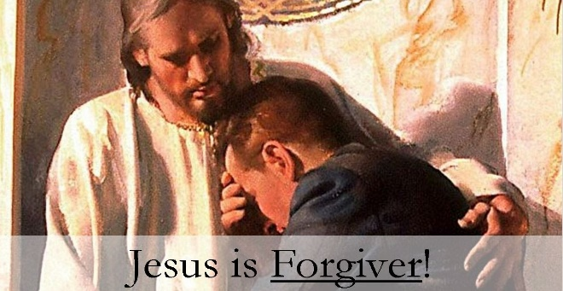
Matthew 18:21-35
A. We were in Debt to Sin with No Possibility of Repayment v23-26
- Our debt was Astronomical, not something we could Repay
- v25 Even your Family could be ordered to be sold to repay your debt
- v26 In Desperation the man cried, “I will pay back Everything!”
- There was no way possible for the man to Repay his master
- It was Inconceivable how he could Gain such a huge debt in the first place
- We were Born in Sin owing an Unbelievable amount of debt
- We could Never do “good enough” to dig ourselves out of the Mountain of debt of Sin
B. Miracle: Jesus Forgave our Debt v27
- v27 The Master had Pity on him and Cancelled his debt
- What amazing Generosity of the Master! He cancelled a debt the servant could Never repay
- Jesus Forgave our Debt and wiped it completely Away
- By His death on the Cross, he paid the Penalty for sin that we owed
- Jesus didn’t just Pardon you; He completely Wiped your debt away
- You don’t need to live in Sin and Shame any longer
C. What Now?
- Live Forgiveness
- Don’t live in Unforgiveness and the Debt of Sin
- Give Forgiveness v28-35
- When we are forgiven, we must pass Forgiveness on to Others
Honolulu Assembly of God Who is Jesus? April 14, 2024

